CUSTOM SCREEN WORKSHEET for VR 3.5” SERIES PHONES
In order to help us process your order for screen design promptly and correctly, please complete this form with all relevant details. Please check to ensure that spelling and your preferences are clearly stated within this document.
For assistance, please contact us: support@aeicommunications.com
Once completed, please email this document back to us at support support@aeicommunications.com

Hotel Property Information
Hotel Name:
Hotel Logo: | Please Provide Logo in Vector Format, (.eps) or (.ai) are acceptable

Room Numbering
Please note: Room Number is displayed on Screen
Please provide a list of Room Numbers on a separate Spreadsheet.

Display - Front Page

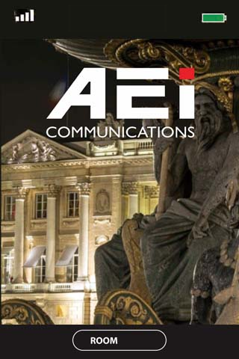

Customization F1 | Target resolution 320 x 352 ; Please provide in Bitmap format (.bmp) | File name

Display – Dialling Procedures Page
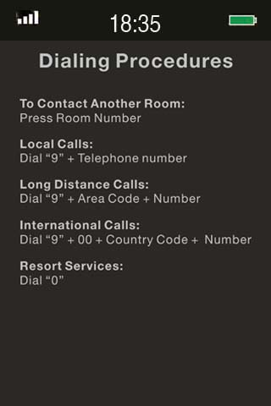

Customizable DB:
Page size: 320x 432 pixels

Items | Format | File name
Customization DB | Target resolution 320 x 432 ; Please provide in Bitmap format (.bmp) | File name

**Multiple languages requirement: Each image with corresponding language (Up to 5 languages)
Multiple languages requirement |  | File name
Customization DB | Target resolution 320 x 432; Please provide in Bitmap format (.bmp) | File name
Customization DB | Target resolution 320 x 432; Please provide in Bitmap format (.bmp) | File name
Customization DB | Target resolution 320 x 432; Please provide in Bitmap format (.bmp) | File name
Customization DB | Target resolution 320 x 432; Please provide in Bitmap format (.bmp) | File name
Customization DB | Target resolution 320 x 432; Please provide in Bitmap format (.bmp) | File name

Display - Serive Page
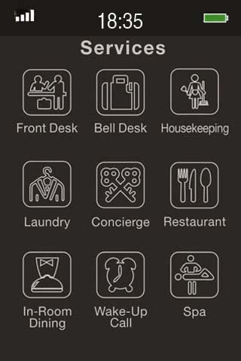
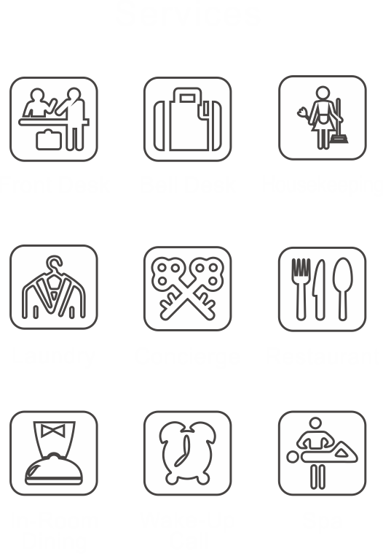
Customizable S1-S9:
Services icon size: 65x65 pixels
S1 S2 S3
S4 S5 S6
S7 S8 S9

Customizable SB:
full size: 320 x 432

Please select from the standard service icons from the last page of this document.

Items | Format | File name | Extension Name | Extension Number to program
Customization SB | Target resolution 320 x 432; Please provide in Bitmap format (.bmp) | File name
Customization S1 | Target Resolution 65 x 65; Please provide in Bitmap format (.bmp) | File name | Extension Name: | Extension Number to program
Customization S2 | Target Resolution 65 x 65; Please provide in Bitmap format (.bmp) | File name | Extension Name: | Extension Number to program
Customization S3 | Target Resolution 65 x 65; Please provide in Bitmap format (.bmp) | File name | Extension Name: | Extension Number to program
Customization S4 | Target Resolution 65 x 65; Please provide in Bitmap format (.bmp) | File name | Extension Name: | Extension Number to program
Customization S5 | Target Resolution 65 x 65; Please provide in Bitmap format (.bmp) | File name | Extension Name: | Extension Number to program
Customization S6 | Target Resolution 65 x 65; Please provide in Bitmap format (.bmp) | File name | Extension Name: | Extension Number to program
Customization S7 | Target Resolution 65 x 65; Please provide in Bitmap format (.bmp) | File name | Extension Name: | Extension Number to program
Customization S8 | Target Resolution 65 x 65; Please provide in Bitmap format (.bmp) | File name | Extension Name: | Extension Number to program
Customization S9 | Target Resolution 65 x 65; Please provide in Bitmap format (.bmp) | File name | Extension Name: | Extension Number to program

**Multiple languages requirement: Each image with corresponding language (Up to 5 languages)
Items | Extension Name in language 1 | Extension Name in language 2 | Extension Name in language 3 | Extension Name in language 4 | Extension Name in language 5
 | English | Jananese | Traditional Chinese
 | Room Service | ル－ムサ－ビス | 客房服務
Service 1 | Extension Name: | Extension Name: | Extension Name: | Extension Name: | Extension Name:
Service 2 | Extension Name: | Extension Name: | Extension Name: | Extension Name: | Extension Name:
Service 3 | Extension Name: | Extension Name: | Extension Name: | Extension Name: | Extension Name:
Service 4 | Extension Name: | Extension Name: | Extension Name: | Extension Name: | Extension Name:
Service 5 | Extension Name: | Extension Name: | Extension Name: | Extension Name: | Extension Name:
Service 6 | Extension Name: | Extension Name: | Extension Name: | Extension Name: | Extension Name:
Service 7 | Extension Name: | Extension Name: | Extension Name: | Extension Name: | Extension Name:
Service 8 | Extension Name: | Extension Name: | Extension Name: | Extension Name:
Service 9 | Extension Name: | Extension Name: | Extension Name: | Extension Name: | Extension Name:

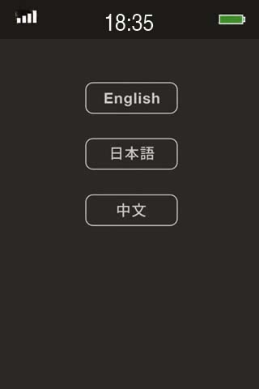
Display - Language Page

Multiple languages requirement. (Up to 5 languages)
Customization CF | Target resolution 258 x 480; Please provide in Bitmap format (.bmp) | File name
Default languages English
Default languages Japanese
Default languages Chinese
Customized language

Display – Control Page

Guest room control systems mostly are developed differently. Every guest room control system will be required new development, compatible implementation, and integrated tests.
Sample user interface are lighting, curtain, and room temperature controls
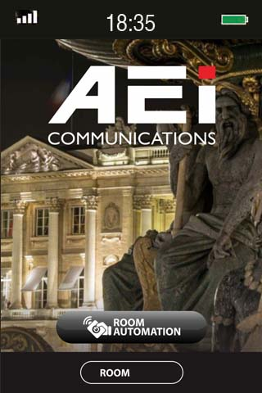
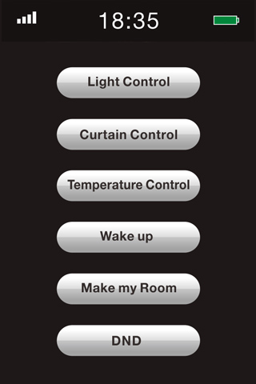
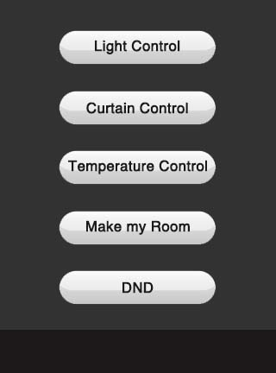
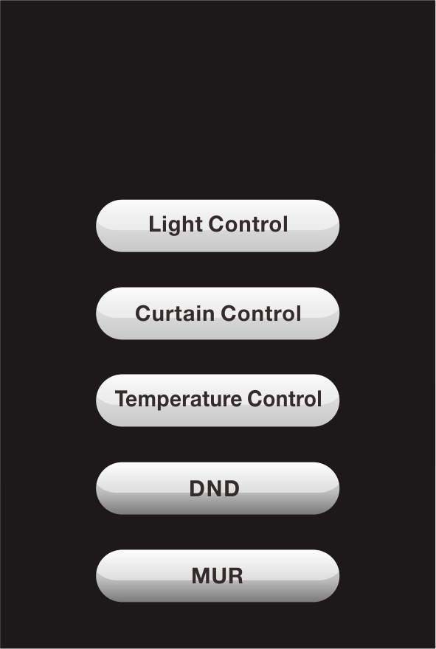

Light Controls
 | Light Control in language 1 | Light Control in language 2 | Light Control in language 3 | Light Control in language 4 | Light Control in language 5
 | Lighting | 点灯 | 燈光
 | Light Control location name in language 1 | Light Control location name in language 2 | Light Control location name in language 3 | Light Control location name in language 4 | Light Control location name in language 5
 | English | Japanese | Traditional Chinese
 | Living Room | 居間 | 客廳
Location 1 | Location | Location | Location | Location | Location
Location 2 | Location | Location | Location | Location | Location
Location 3 | Location | Location | Location | Location | Location
Location 4 | Location | Location | Location | Location | Location
Location 5 | Location | Location | Location | Location | Location
Location 6 | Location | Location | Location | Location | Location
Location 7 | Location | Location | Location | Location | Location
Location 8 | Location | Location | Location | Location | Location
Location 9 | Location | Location | Location | Location | Location

Curtain Controls
Items | Curtain Control in language 1 | Curtain Control in language 2 | Curtain Control in language 3 | Curtain Control in language 4 | Curtain Control in language 5
 | Curtain | カーテン | 窗簾
Items | Curtain Control location name in language 1 | Curtain Control location name in language 2 | Curtain Control location name in language 3 | Curtain Control location name in language 4 | Curtain Control location name in language 5
 | English | Japanese | Traditional Chinese
 | Living Room | 居間 | 客廳
Location 1 | Location | Location | Location | Location | Location
Location 2 | Location | Location | Location | Location | Location
Location 3 | Location | Location | Location | Location | Location

Temperature Controls
Items | Temperature Control in language 1 | Temperature Control in language 2 | Temperature Control in language 3 | Temperature Control in language 4 | Temperature Control in language 5
 | Room Temperature | 室温 | 客房溫度
Items | Temperature Control location in language 1 | Temperature Control location in language 2 | Temperature Control location in language 3 | Temperature Control location in language 4 | Temperature Control location in language 5
 | English | Japanese | Traditional Chinese
 | Living Room | リビングルーム | 客廳
Location 1 | Location | Location | Location | Location | Location
Location 2 | Location | Location | Location | Location | Location
Location 3 | Location | Location | Location | Location | Location

DND/MUR
Items | language 1 | language 2 | language 3 | language 4 | language 5
DND | Do Not Disturb | 起こさないでくささい | 請勿打擾
MUR | Make Your Room | 部屋作り | 請整理客房


