C
CUSTOM FACEPLATE WORKSHEET for GR-8106-SPC phones

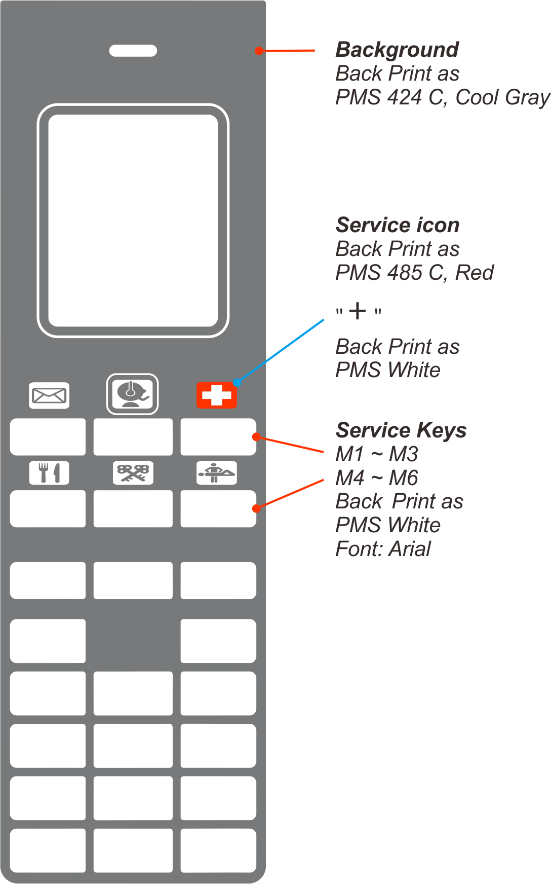
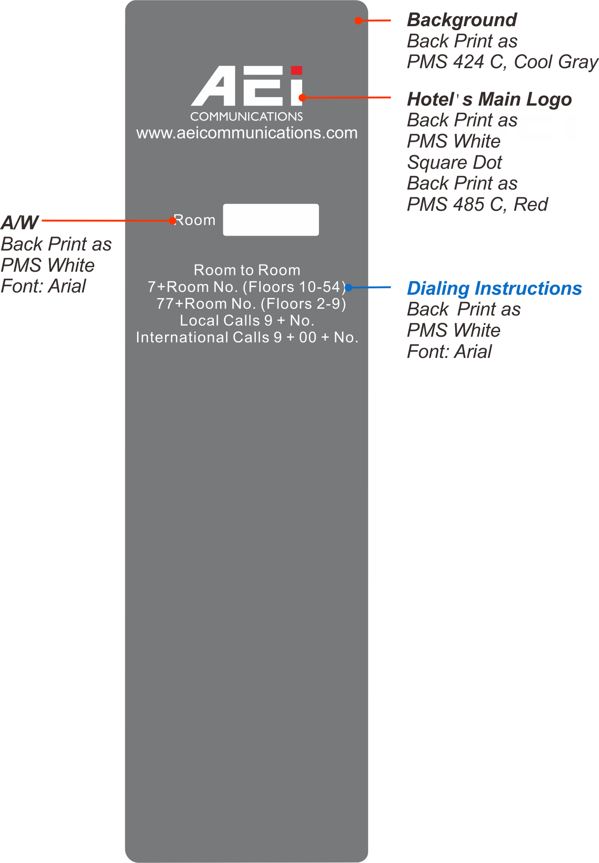
Handset Base



CUSTOM FACEPLATE:
In order to help us process your order for custom faceplates promptly and correctly, please complete this form with all relevant details. Please check to ensure that spelling and your preferences are clearly stated within this document.
Notes:
- Please look at the examples within this document for ideas on how to fill out form.
- You will receive a final proof for your approval.
For assistance completing this form, please contact us: support@aeicommunications.com
Once completed, please email this document back to us at: support@aeicommunications.com
Hotel Property Information
Hotel Name:
Hotel Address:
(Please separate address lines the way you would like them to appear on the faceplate)
Hotel Telephone Number:
Hotel Fax Number:
Hotel Email Address:

Order Details
Required Delivery Date:
Telephone Model:
Faceplate Quantity:
Faceplate Color:
Text / Typeface Ink Color:
Symbols Ink Color:
Standard Specifications colors are as follows: Pantone 424C (gray) faceplate , black text / typeface and black symbols.
-8106-SMK Phones
Logo
Important Note: Please provide us with your logo and any other requisite branding, the way you would like them to appear on the faceplate. This can be emailed to us as an attachment, preferably as a high quality image file such as “.eps “, “ .ai” (Adobe Illustrator), or “.cdr” (Corel Draw).
Please specify the name of file(s)?
Please add any other information relating to the positioning of the logo and any other preferences:

Room Numbering
Please note: Faceplate Room Numbering is offered via transparent adhesive printed labels which can be placed in the appropriate position on the standard printed faceplate. By default we will send these for your staff to apply.
Is Room Numbering Required**?
If Yes, how many?
**If Yes, please submit a list containing the room numbers you would like to have printed and the quantity of each that should be printed. E.g. Room 102 - 2 units.
If No, should a blank room number box be printed?

Dialing Instructions
Order of printing: | Service | Instructions
Example:
3 | Local Calls | Dial “9” + Number
Please note: If you have an existing faceplate which you would like copied, please e-mail it to us.

Guest Service (Speed Dial) Key Labelling & Key Programming
Key Number: | Icon Symbol Number: | Above or  Below Key  (please indicate) | Text: | Above or  Below Key  (please indicate) | Key Programming  Extension
1
2
3
4
5
6

Please Return Completed Form to:
Email: support@aeicommunications.com

