CUSTOM SCREEN WORKSHEET for VX-8108-SMBU(S) SERIES PHONES
In order to help us process your order for screen design promptly and correctly, please complete this form with all relevant details. Please check to ensure that spelling and your preferences are clearly stated within this document.
For assistance, please contact us: support@AEIcommunications.com or call: 1.(650) 552.9416
Once completed, please email this document back to us at: support@AEIcommunications.com.
Hotel Property Information
Hotel Name :
Hotel Logo: | Please Provide Logo in Vector Format, .eps or .ai are acceptable

Room Numbering
Please note: Room Number is displayed on Screen
Please provide a list of Room Numbers on a separate spreadsheet.

7 Selectable Guest Service Screen Memories (Soft Keys), arranged in Carrousel form
Order | Icon Number:  (See last page) | Extension Name: | Extension Number to program
EX | 1G | Guest Services | 1234
1
2
3
4
5
6
7
Note : Select 7 extensions to be displayed in Carrousel form on the screen. Icon 4, is assigned as the center of the Carrousel, refer to the next page graphic

3 Pre-Set Direct Dial Keys “Hard Keys” on the Keyboard
Icon Number:  (See last page) | Extension Name: | Extension Number to program
 | Message
 | Guest Services
 | Emergency

SAMPLE VX HANDSET SCREEN

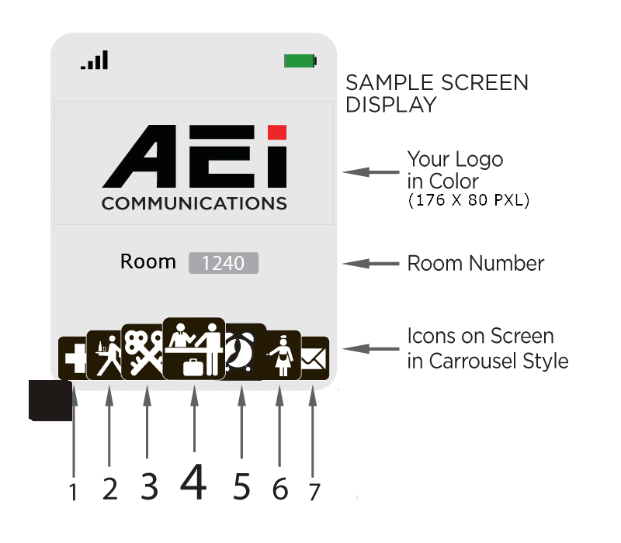

.
NOTE 1
Icon 4 is by default centered on the Carrousel.
Icon 4 is the icon with direct access to the user.

NOTE 2
When making your selection of Extensions and Icons for the Screen,
Remember that the following are already Pre-set on the keyboard (Hard Keys)
Message
Guest Services
Emergency
However it is possible to duplicate them on the carrousel if desired

Dialing Instructions for LCM display
Order
Example | Room to Room: | 1 + Room Number
1
2
3
4

SAMPLE BASE STICKER




