CUSTOM FACEPLATE WORKSHEET for VM-8200-SMKLT(S)

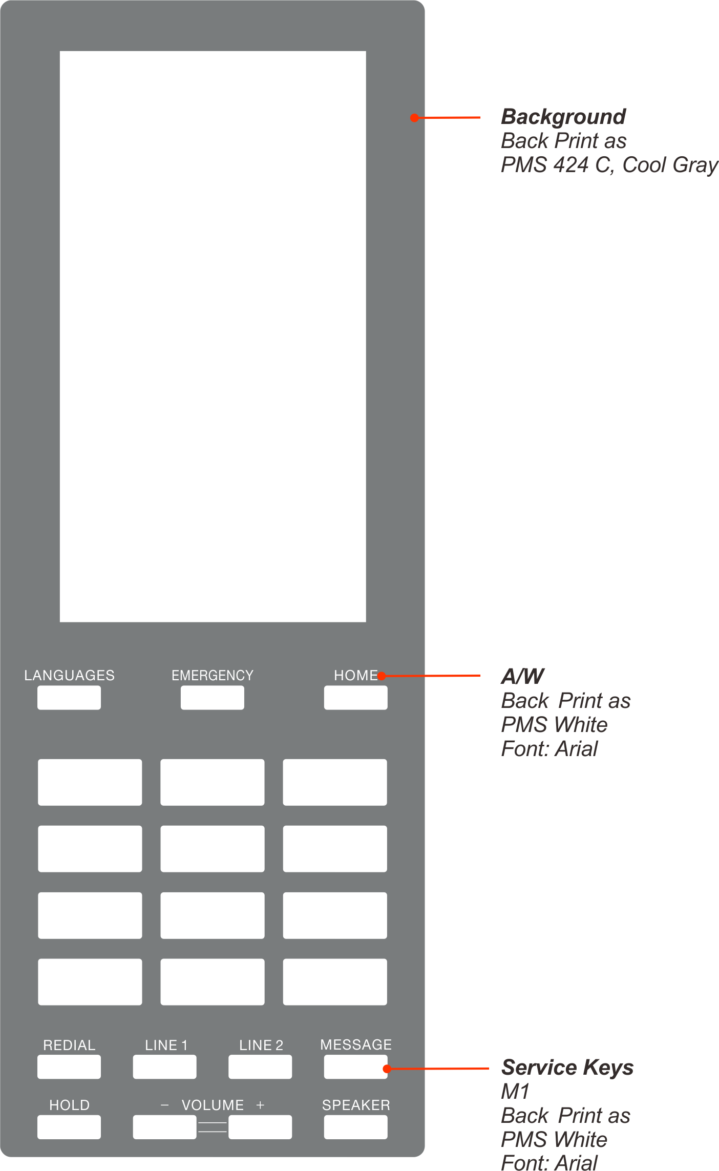

SAMPLE VM HANDSET SCREEN

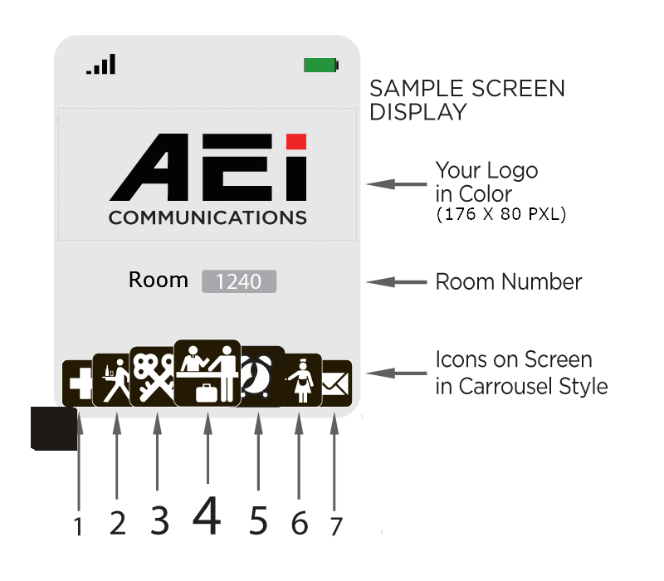

.
NOTE 1
Icon 4 is by default centered on the Carrousel.
Icon 4 is the icon with direct access to the user.

NOTE 2
When making your selection of Extensions and Icons for the Screen,
Remember that the following are already Pre-set on the keyboard (Hard Keys)
Message
Guest Services
Emergency
However it is possible to duplicate them on the carrousel if desired
.


7 Selectable Guest Service Screen Memories (Soft Keys), arranged in Carrousel form
Order | Icon Number:  (See last page) | Extension Name: | Extension Number to program
1
2
3
4
5
6
7
Note : Select 7 extensions to be displayed in Carrousel form on the screen. Icon 4, is assigned as the center of the Carrousel, refer to the next page graphic

3 Pre-Set Direct Dial Keys “Hard Keys” on the Keyboard
Icon Number:  (See last page) | Extension Name: | Extension Number to program
 | Message
 | Front Desk
 | Emergency

Dialing Instructions for handset LCM display
Order
Example | Room to Room: | 1 + Room Number
1
2
3
4

CUSTOM FACEPLATE:
In order to help us process your order for custom faceplates promptly and correctly, please complete this form with all relevant details. Please check to ensure that spelling and your preferences are clearly stated within this document.
Notes:
- Please look at the examples within this document for ideas on how to fill out form.
- You will receive a final proof for your approval.
For assistance completing this form, please contact us: support@aeicommunications.com

Once completed, please email this document back to us at: support@aeicommunications.com

Hotel Property Information
Hotel Name:
Hotel Address:
(Please separate address lines the way you would like them to appear on the faceplate)
Hotel Telephone Number:
Hotel Fax Number:
Hotel Email Address:

Order Details
Required Delivery Date:
Telephone Model:
Faceplate Quantity:
Faceplate Color:
Text / Typeface Ink Color:
Symbols Ink Color:
Standard Specifications colors are as follows: Pantone 424 (gray) faceplate , black text / typeface and black symbols.
Logo
Important Note: Please provide us with your logo and any other requisite branding, the way you would like them to appear on the faceplate. This can be emailed to us as an attachment, preferably as a high quality image file such as “.eps “, “ .ai” (Adobe Illustrator), or “.cdr” (Corel Draw).
Please specify the name of file(s)?
Please add any other information relating to the positioning of the logo and any other preferences:

Room Numbering
Please note: Faceplate Room Numbering is offered via adhesive printed labels which can be placed in the appropriate position on the standard printed faceplate. By default we will send these for your staff to apply.
Is Room Numbering Required**?
If Yes, how many?
**If Yes, please submit a list containing the room numbers you would like to have printed and the quantity of each that should be printed. E.g. Room 102 - 2 units.
If No, should a blank room number box be printed?

Dialling Instructions
Order of printing: |  | Service |  |  | Instructions
Example:
3 |  | Local Calls |  |  | Dial “9” + Number
Guest Service (Speed Dial) Key Labelling
Key Number: | Icon Symbol Number: |  | Above or  Below Key  (please indicate) | Text: |  |  | Above or  Below Key  (please indicate) | Speed Key Programming
1 |  |  | Above / Below |  |  |  | Above / Below
2 |  |  | Above / Below |  |  |  | Above / Below
3 |  |  | Above / Below |  |  |  | Above / Below
4 |  |  | Above / Below |  |  |  | Above / Below
5 |  |  | Above / Below |  |  |  | Above / Below
6 |  |  | Above / Below |  |  |  | Above / Below
7 |  |  | Above / Below |  |  |  | Above / Below
8 |  |  | Above / Below |  |  |  | Above / Below
9 |  |  |  | Message (default)
 |  |  |  |  |  | Example:
1 | 1A |  | Above / Below | Reception |  |  | Above / Below

Please note: If you have an existing faceplate which you would like copied, please email to us.

Please Return Completed Form to:
Email: support@aeicommunications.com

